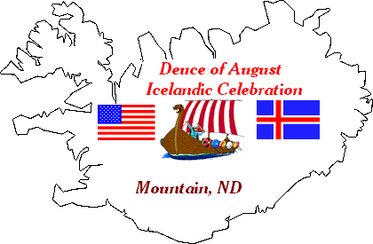
Fjalla Blað
Thirteenth Edition 2008

Mountain Chat
“Hvað er svo glatt
sem góðra vina fundur?“

I. C. A.
P.O. Box 63
Mountain, ND 58262-0063
“What is as joyful as a
gathering of good friends?“

labration

Farsælt Komandi ár
Happy New Year

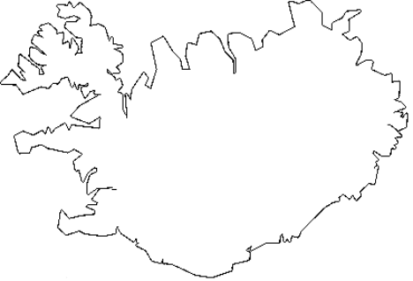
NON PROFIT ORG.
US POSTAGE
PAID
MOUNTAIN, ND 58262
PERMIT # 4

Fjalla Blað
Icelandic Communities Association
POB 63
Mountain, ND 58262-0063
USA

----------------------------

Gearing up for the

109th Annual Deuce of August Icelandic Celebration
August 1st, 2nd & 3rd
Mountain, ND

THOUGHT YOU’D LIKE TO KNOW:
Our Celebration will always be held on the weekend preceding the first Monday in August!
This enables visitors to also attend the Islendingadagurinn in Gimli on the first Monday in August.
2008-109th Deuce of August Celebration--Friday, Saturday, & Sunday--August 1st, 2nd & 3rd
2008 is the 130th anniversary of the settlement of the Icelandic Communities in Northeastern North Dakota!

President, Curtis Olafson-13041 84th St.NE-Edinburg,ND 58227-Ph. 701-993-8240-E-Mail-colafson@polarcomm.com
Vice-President, Leslie Geir-8517 Hwy. 32-Edinburg,ND 58227-Ph. 701-993-8367-E-Mail-lesgr@polarcomm.com
Secretary, Loretta Bernhoft-P.O. Box 204-Mountain,ND 58262-Ph. 701-993-8282-E-Mail-bernhoft@polarcomm.com
Treasurer, Bjork Olafson-13041 84th St.NE-Edinburg,ND 58227-Ph. 701-993-8240-E-Mail-bjork@polarcomm.com
Editor, Duane Halldorson-P.O. Box 064-Mountain,ND 58262-Ph. 701-993-8116-E-Mail-halldor3@polarcomm.com

I would like to remind you that if you have any friends you think might enjoy getting this newsletter have them drop us a line with their mailing address or e-mail address and a brief note on how they heard about us. Please feel free to contact us at any time at the Icelandic Communities Assoc., PO Box 063, Mountain, ND 58262-0063, Phone# 701-993-8268 - E-Mail (august2@polarcomm.com) - Fax,(701-993-8239) Also, don’t forget to check out our Web Page (www.august2nd.com) for up to date information on our Celebration plans and other activities.

The 2008 Membership drive is underway.
Membership runs from Jan. thru Dec.
$10.00 per person
Any Membership payment that arrives after November 15th of that year will be applied to the following year.

NOTE: Membership dues are not tax deductible, but any contributions over and above that are tax deductible.
ICA has 501 c 3 (tax-exempt non-profit) status from the Internal Revenue Service.

NOTE: You may pay your dues in advance.
“Please note on your check which year’s dues you are paying”

2007 Deuce of August
$1000 & $500 ICA MONEY RAFFLE.
Drawing was held August 3rd after Tractor Pull
2007 Winners were
$1000-Bruce Hanson-$500-Randy Mastre
Both from Park River, ND

Our Raffle Ticket Super Salesman for 2007 was once again Arvid Knutson.
Thanks Arvid for all your hard work.

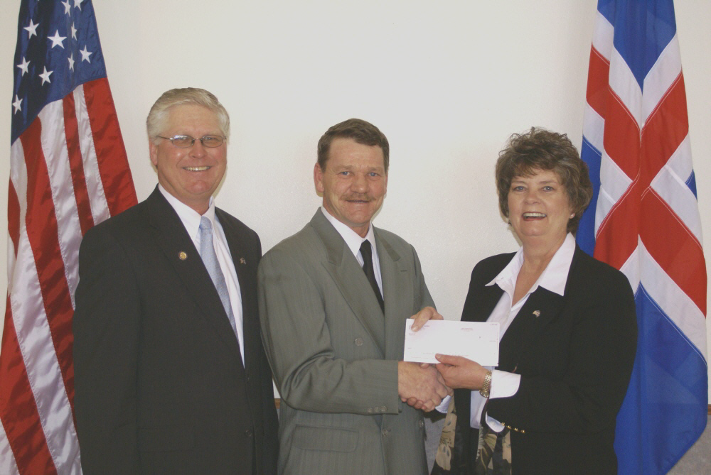
Loretta Bernhoft, Iceland's Honorary Consul to North Dakota, presents a check on behalf of the Government of Iceland to Mountain Mayor and Capital Campaign Co-Chairman Tim Moore, (pictured center) and Capital Campaign Co-Chairman Curtis Olafson

Government of Iceland Donates $75,000 to Mountain Community Center
The Mountain Community Center Capital Campaign Committee has announced that the Government of Iceland has approved a major contribution to the Community Center project. Iceland’s Prime Minister Geir H. Haarde attended the 108th Annual Deuce of August Icelandic Celebration in Mountain in August of 2007 and learned of the project. The Committee submitted a request for funding following his visit and the Government of Iceland recently approved a $75,000 contribution for the project. In announcing the contribution, Prime Minister Haarde said, "The Government of Iceland is pleased to support this very worthwhile project. The ongoing effort by our family and friends in North Dakota to preserve and honor their rich and unique Icelandic heritage, history and culture is an inspiration to the people of Iceland. We recognize the necessity of this project and the commitment of those who are involved in the planning and fundraising, and we feel that it is important for us to assist them in their efforts." Prime Minister Haarde has twice visited North Dakota and taken part in the annual Icelandic Celebration in Mountain, first in 2004 in his capacity as Iceland’s Finance Minister, and most recently during the 2007 Celebration.
Tim Moore, Capital Campaign Committee Co-Chairman and Mountain Mayor, said, “This contribution is a big step forward for our fundraising effort, and we are very thankful for this strong support from Iceland. Our project is designed to serve not only the needs of the community of Mountain, but will have the capability to serve as a regional center for a variety of needs and events.” Curtis Olafson, who also serves as Co-Chairman of the Committee said, “This very generous contribution is greatly appreciated, and came about as a result of the close bonds that have developed over the years between the people of Iceland and the people of Icelandic descent here in North Dakota. We are privileged to have hosted many tour groups, guests, and dignitaries from Iceland over the years, and they are fascinated with our area and our way of life. More importantly, they are moved by our passion for celebrating and preserving our Icelandic heritage.”
The Committee will continue its fundraising effort to reach the goal of matching the $676,000 in federal grants which have been approved for the project. The public fundraising effort was launched in July of 2007 and is now approaching the $300,000 mark in funds which have been donated or pledged and will be used to match the federal dollars. The projected cost of the new building is $1,260,000. The Capital Campaign Committee sincerely appreciates the support received from all donors. For further information on supporting this project, visit the fundraiser website at www.mountainnd.com

Mountain Community Center NEWS!!!
Submitted by Loretta Bernhoft
We would like to thank the approximately 165 individuals across the US who have taken a leap of faith and made a donation to the Mountain Community Center Capital Campaign!! We sincerely appreciate all of your contributions!!
Recently we raised $2000 at a Chili/Baked Potato supper and the publicity generated by that event produced another $10,000 in donations within two weeks.
Several area corporate sponsors have also made the decision to financially support this project and we are also grateful for their commitment. We recently learned that the enthusiasm has spread worldwide as the government of Iceland announced that they would contribute $75,000 toward the Community Center! Watch for further information concerning this wonderful gift!!
Check out our website at www.mountainnd.com. We appreciate your input! (continued)
Corporate Sponsors

North Star Community Credit Union $10,000
United Valley Bank $ 5,000
Farm Credit Services $ 1,500
Polar Communications $ 2,550
Farmer’s Union Oil Adams $ 2,500
Mountain Quick Response $10,000
Mountain Fire Department Gaming $12,000
Tri-County Trail Riders Snowmobile Club $ 5,000
Park River Dental Office $ 100
H & R Block Jim Christianson $200
Park River Veterinary Clinic $ 25
Harold Myrdal Steam & Clean $100
Cavalier Presbyterian Women $500
Citizen’s State Bank-Midwest $200
L.R. C-Store, LLC $100
Edinburg General Store $ 50
Langdon Food Services $250

Government of Iceland $75,000

President’s Message

Curtis Olafson

Greetings to all of our friends and supporters. The 108th Deuce of August Celebration held this past summer will certainly be one of the most memorable Celebrations ever! The weather was great, the attendance at all events met or exceeded our expectations, and a lot of people had a fun-filled weekend. We were greatly honored to have many special guests, including Iceland Prime Minister Geir H. Haarde, North Dakota Governor John Hoeven, Albert Jónsson, Iceland’s Ambassador to the United States, Garry Oddleifson, President of the Icelandic National League of North America, Almar Grímsson, President of the Icelandic National League of Iceland, and Valgeir Þórvaldsson, Managing Director of the Icelandic Emigration Center at Hofsós, Iceland. In addition to the many dignitaries that we were privileged to host, we also had about 200 guests from Iceland joining us, and friends from all over the US and Canada. There were a lot of different license plates traveling up and down the streets of Mountain during the Celebration weekend! The Icelandic Communities Association, the community of Mountain, and all of our supporters throughout the area can be very proud of the great success we enjoyed in showcasing our area, the state of North Dakota, and our great pride in our Icelandic heritage.

We have begun planning another great Celebration for 2008, so mark your calendars now for the 109th Annual Celebration on August 1st, 2nd and 3rd. It is always fun when our big day actually falls on August 2nd, and that is the case this year. Watch for more information in a later newsletter, and check out our website at www.august2nd.com to learn more as we continue to make our plans for this summer.

I would like to take the opportunity of this President’s Message to share some thoughts with you about the plans for the new Mountain Community Center. The very generous contribution from Iceland which is highlighted at the beginning of this newsletter is very exciting news for this project. Our public fundraising effort started in July of 2007, after years of planning by some very dedicated people. The fundraising has been going very well, and we sincerely appreciate all the donors who believe in the future of our community, and have offered their support. We still need more of our friends and supporters who have not yet made a commitment to the project to join us in moving the project to completion. If you have been waiting to see how the fundraising effort would develop, now is the time to join your many friends and neighbors who have chosen to stand up and put their name and their money forth in support of this project. Check out the fundraiser website at www.mountainnd.com for updated information, and watch your mailbox for a letter providing more detailed information on the current financial status of the fundraising effort. We look forward to seeing you in Mountain this summer for the 109th Annual Deuce of August Celebration!

.

Genealogy Center……………..George Freeman
At the Genealogy Center last August we were better prepared and more capable of helping people finding their ancestors and cousins. We did help people, as much as 2 people can do on a weekend. Pam Furstenau & I took some of the requests home to finish after the weekend. We had a live audio-visual hookup over the internet with Halfdan Helgason of Iceland that helped a few people.
The real story about relatives finding each other happened mostly outside the Genealogy Center. One situation happened when someone from Iceland asked Kathy Thorlackson if she knew someone. Kathy replied “why yes she lives across the hall from my mother.” The next thing Kathy knew the Icelander and American cousin were sitting outside Borg Home on a bench singing Icelandic songs. I heard of four other situations where Icelanders met their American cousins. Isn’t that great? So the lesson is to talk to our Icelandic visitors. You may meet a cousin.
We were disappointed that the Native Americans couldn’t make it to the celebration. We will try harder to get them to the celebration next year. David Hillman is in charge of that.
Tim & Sue Powers graciously will let us use their home NE of the Fire Hall again. Souvenirs will be sold in the garage of their home.
Pam Furstenau (pam@rootstotrees.com)(http://www.rootstotrees.com) and George Freeman (gfreeman@gra.midco.net)(http://www/laxakin.com) will be the researchers at the center. We may get some help from Shirley Olgeirson (bigyellowhouse1904@hotmail.com) as well. We hope to get some support from Magnús Haraldsson and Hálfdan Helgason from Iceland across the internet again. If there is another genealogist that would like to help please contact either Pam or George. We are somewhat limited in space but can have one or two more researce

From The Souvenir Shop
Jeanne Halldorson
Spring is right around the corner along with Valentine’s Day, Easter, weddings, Mother’s Day, graduations, birthdays, and Father’s Day. Our souvenirs make wonderful and unique gifts for almost any occasion. We still have a limited amount of hardfiskur, which is being sold on a first come first served basis. The INL Calendars this year feature 13 North American Icelandic Churches including Vikur Lutheran Church in Mountain and Thingvalla Lutheran Church at Eyford, North Dakota. Recently a limited number of Thingvalla Lutheran Church Memorial Plates were found. They are for sale for $20.00 each. A new item we have this year are red and blue marbled silicone bracelets. They are embossed with “Deuce of August, Mountain ND”. Prices are as follows:

VISORS……………………$15.00 BASEBALL CAPS……………………………. $15.00
ADULT T-SHIRTS……… $15.00 KIDS T-SHIRTS………………………………. $12.00

TOTE BAGS……………… $12.00
APRONS………………… $15.00
HOT PADS……………… $ 8.00
ONESIES………………… $12.00
ICELANDERS IN DAKOTA DVD’S...$15.00
ICELANDERS IN DAKOTA VIDEO TAPES...$12.00
LIFE IN THE VAST LANE” POSTERS……....$20.00
HARDFISKUR..………………………………. $15.00
2008 INL CALENDARS………………………$10.00
THINGVALLA CHURCH PLATES…………. $20.00
BRACELETS…………………………………..$3.00
221 MELSTED PLACE COOKBOOKS............$15.00

To place an order e-mail me at jeanne1@polarcomm.com or call me at 701-993-8116.
All orders are mailed insured priority mail

2007 I.C.A. Memberships

Abrahamson | Andrea
Abrahamson | Eric
Abrahamson | Jana
Abrahamson | Jonathan
Abrahamson | Karen (Hillman)
Abrahamson | Karie
Abrahamson | Karl
Anderson | Duane & Emilía (Jónsdóttir)
Axelson | Cobie (Bjornson)
Barrett | Tom & Cindy
Baumgardner | Cindy (Stefanson)
Benjaminson | Connie
Benjaminson | George
Benjaminson | Paul
Bernhoft | Neil & Melaine (Nordquist)
Bernhoft | Orville & Judy (Einarson)
Bernhoft | Ryan & Stacie (Larson)
Bernhoft | Wayne & Loretta (Thorfinnson)
Biliske | Eleanor (Geir)
Biliske | Sylvia E. (Hallgrimson)
Biliski | Dennis & Sue
Bjornson | Fred K.
Bjornson | Richard & Janyce (Gudmundson)
Bjornstad | Jeanette (Johnson)
Blair | Jacque
Bleakley | Bev (Einarson)
Borelli | Sigrid (Hallgrimson)
Bowles | John & Laurel (Laxdal)
Briese | Gloria
Brown | Tom & Pat (Cranston)
Busch | Karen (Thordarson)
Busch | Margaret (Thordarson)
Byron | Andrew & Gwennie (Beard)
Byron | Chris & Cecelia (Adams)
Byron | Gerald & Lisa (Holliday)
Carpenter | Eugene & Jackie (Thorfinnson)
Carpenter | Noreen (Johnson)
Christianson | Arnold & Donna (McDonald)
Cox | Gladys (Finnson)
Davidson | Erlins & Patricia
Davidson | Ronald & Martha
Diaz | Frances
Einarson | Betty (Hughes)
Erickson | Carl & Marcella (Kristjanson)
Fafnis | Reynis
Franks | Carol
Freeman | George
Furstenau | Jeff & Pam (Olafson)
Gamons | Ellen
Geir | Duane & Carolyn
Geir | Leslie
Gudmundson | Chad & Janna (Brandvold)
Gudmundson | Keith
Gudmundson | Kenneth & Sondra
Gudmundson | Shirley (Bourbanis)
Hall | Alfred
Hall | Christine (Geir)
Halldorson | Ashley
Halldorson | Barney
Halldorson | Dennis
Halldorson | Duane & Jeanne (Jacks)
Halldorson | John
Halldorson | Kenneth & Karen (Carlson)
Halldorson | Nicky
Halldorson | Richard & Ellyn (Brown)
Hammer | Bev (Nelson)
Heck | Scott
Helgisdóttir | Amanita M.
Helgoe | Lee & Viola (Halldorson)
Hendrickson | Dorothy (Johnson)
Herzog | Douglas
Hillman | Andrea
Hillman | David
Hillman | RS Lyle & Diane
Holand | Kenneth & Evelyn
Holliday | Orval
Hughes | Christine (Bjornson)
Isfeld | Sigurd
Jensen | Ray
Johannesson | Ingibjorg (Heigaard)
Johannesson | Keith
Johannson | Kenneth F.
Johnson | Arni & Dolores (Gaffney)
Johnson | Dawn (Benjaminson)
Johnson | Doreen (Bjornson)
Johnson | Jim & Marilyn (Halldorson)
Johnson | John
Johnson | John & Darlene (Hunt)
Johnson | Lillian
Johnson | Margie (Jonasson)
Johnson | Verna
Johnson | Victor & Dorothy
Johnston | Elizabeth
Jonasson | Esther (Baarstad)
Jonasson | Robert & Rosemarie
Kenney | Darlene
Knutson | Arvid & Darlene (Bjornson)
Kopf | Bernadine
Kristjanson | Alfred
Kristjanson | Ingibjorg (Hallgrimson)
Kuhlmann | Anna (Isfeld)
Lagen | Nicolette (Biliske)
Laxdal | Edward & Elaine (Thorfinnson)
Laxdal | Sharon (Indergaard)
Leahy | Sylvia K. (Sigurdson)
Lorenzen | Margaret (Olgeirson)
Machacek | Donald & Bessie (Hallgrimson)
Masar | Harold
Mathewson | Elin (Melsted)
McNamara | Margaret (Stanton)
Melsted | Steven
Melsted | Waldemar & Ida (Dearinger)
Mickels | Sven & Lynda (Benjaminson)
Mohagen | Jane (Benjaminson)
Moore | Timothy & Sylvia
Morrison | Emily (Christianson)
Morrison | Pat (Nason)
Myrdal | Donald & Lillian (Helgason) (Hall)
Nason | Norma (Johnson)
Neuhalfen | Jim
Northfield | Ray & Amy (Kristjanson)
Olafson | Curtis & Björk (Eiriksdottir)
Olafson | Dean
Olafson | Doran
Olafson | Drew & Samantha (Swanson)
Olafson | Eugene
Olafson | Judith ( Sigurdson)
Olafson | Kristi
Olafson | Magnus
Olafson | Robert M.
Olafson | Robert & Betty (McDonald)
Olafson | Roger & Marilyn (Olson)
Olgeirson | Robert
Otto | Austin & Doris (Biliske)
Paulson | Beverly
Paulson | Robert
Peterson | Kris & Dorothy (Einarson)
Powers | Tim & Susan (Sigurdson)
Prien | Bryan
Prien | Debbie (Halldorson)
Prien | Megan
Readel | Kathlyn
Readel | Margaret (Geston)
Readel | Ross & Myrna
Rinaldi | Sue (Herman)
Robinson | Dorothy (Moore)
Rollin | Leon & Mae (Heigaard)
Schroeder | Theodore & Lorraine (Bjornson)
Selzer | Greg & Renata (Olafson)
Sigmar | Ethel
Sigurdson | Joe & MaryAnn (Christianson)
Sigurdson | Shirley Jo
Springer | Gary & Laureen (Snydal)
Stanford | Cheri (Olafson)
Stanton | Lara K. (Kristjanson)
Stefanson | Effie (Einarson)
Steinolfson | Marino & Doris (Goodman)
Sturlaugson | Lee & Bonnie
Thompson | Charles & Ann (Melsted)
Thompson | Lawrine & Norma (Laxdal)
Thorfinnson | Craig & Margaret (Strand)
Thorfinnson | Jamie
Thorfinnson | Kristin
Thorfinnson | Sean
Thorlakson | Mark
Tiffany | Norma (Asta Myrdal)
Timian | Carol (Christianson)
Vatnsdal | Gene & Judy
Vatnsdal | Will
Volrath | Lon & Diane
Vork | Marina (Johannesson)
Wakeford | Andy
Warmoth | Beatrice (Snydal)
Watson | Jo Ann (Geir)
Wessels | Doug & Lorraine (Johnson)
Wild | Lillian (Snydal)
Wild | Richard & Mary (Bjornson)
Williams | Mike & Ramona
Williamson | Allan & Marvel (Kristjanson)
Wright | George & Sandra (Matthiasson)

2007 Contributions

Bernhoft | Wayne & Loretta (Thorfinnson)
Byron | Andrew & Gwennie
Helgisdóttir | Amanita M.
Hillman | Andrea
Rollin | Leon & Mae (Heigaard)
Johnson | Margie (Jonasson)
Olafson | Judith ( Sigurdson)
Rinaldi | Sue (Herman)
Rollin | Leon & Mae (Heigaard)
Polar
Rinaldi | Sue (Herman)
Wright | George & Sandra (Matthiasson)

 | I.C.A. Gold Membership
In Memory  Plaque  Group  Members |  | Great Grandparents  Gamaliel & Katrin Thorleifson &  Fred & Gunnel (Bjarnson) Halldorson  Grandparents  Fridjon & Laufey (Halldorson) Thorleifson
Marcil |  | Michael | Fargo, ND
Fretto |  | Jackie (Marcil) | Glendale, AZ
Marcil |  | Kathy | Scottsdale, AZ

2007 Memorials

Memorial | Dovane Losee
Nason | Norma
Memorial | Neil Kelley
Kelley | Lonnette
Thorfinnson | Rosa
Halldorson | Duane & Jeanne
Memorial | Arthur Leahy
Sylvia K. | Leahy

“Thank You Early Birds”-- 2008 Membership

Benjaminson | George
Benjaminson | Paul
Blair | Jacque
Byron | Chris & Julie
Davidson | Ronald & Martha
Diaz | Frances
Fredericksen | Heather (Prien)
Fredericksen | Ms. Alexis
Furstenau | Jeff & Pam (Olafson)
Gamons | Ellen
Halldorson | Ashley
Halldorson | Barney
Halldorson | Duane & Jeanne (Jacks)
Halldorson | John
Halldorson | Kenneth & Karen (Carlson)
Halldorson | Nicky
Halldorson | Richard & Ellyn (Brown)
Hemsher | Pandora (Byron)
Hendrickson | Dorothy (Johnson)
Herzog | Douglas
Johnson | Dawn (Benjaminson)
Johnson | Jim & Marilyn (Halldorson)
Johnson | Lillian
Johnston | Elizabeth
Kenney | Darlene
Kopf | Bernadine
Kristjanson | Ingibjorg (Hallgrimson)
Leahy | Sylvia K.
Machacek | Donald & Bessie (Hallgrimson)
Mohagen | Jane (Benjaminson)
Morrison | Pat (Nason)
Myrdal | Rosemarie
Nason | Norma (Johnson)
Olafson | Robert & Betty
Olgeirson | Robert
Paulson | Beverly
Perila | Joyce
Powers | Tim & Susan (Sigurdson)
Prien | Bryan
Prien | Debbie (Halldorson)
Prien | Megan
Sigmar | Ethel
Stanton | Lara K. (Kristjanson)
Thompson | Lawrine & Norma (Laxdal)
Thorfinnson | Craig & Margaret (Strand)
Thorfinnson | Jamie
Thorfinnson | Kristin
Thorfinnson | Sean
Vatnsdal | Gene & Judy
Volrath | Lon & Diane
Watson | Jo Ann (Geir)
Wild | Richard & Mary (Bjornson)
Williamson | Allan & Marvel (Kristjanson)

Kitchen Korner
Jeanne Halldorson

“EPLA BAKA” (APPLE PIE)
The following recipes are all similar but have subtle differences. All you have to decide is which one would tickle your fancy. Or you can use my method to choose. Tape all three recipes to the kitchen wall. Put on a blindfold and throw a dart at the wall. Use the recipe that the dart sticks in. Of course, if your aim is like mine the blindfold is completely optional.
ICELANDIC EPLA BAKA
(rec’d from Leslie & Chris Geir)
1-1/2 cups sugar 2 eggs
1 cup flour 1 tbsp. Vanilla
2 tsp. baking powder 2 cups diced apples
½ tsp. cinnamon ½ cups chopped nuts
½ tsp. salt whipped cream
½ tsp. nutmeg
Mix the first six ingredients thoroughly. Add eggs, vanilla, apples and nuts. Grease two 8” pie pans. Pour ½ of mixture in each pan. Bake at 350* for 35-40 minutes. Pie makes its own crust. Top with whipped cream.

NORWEGIAN APPLE PIE
(rec’d from Esther Jonasson)
1 egg ¾ cup sugar
1 tsp. vanilla ¼ tsp. salt
½ cup flour 1 cup diced apple
½ cup chopped nuts
With a wooden spoon, in a large bowl, mix together the first five ingredients in order. Fold in the diced apples and chopped nuts. Place mixture in greased 8” pie pan. Bake at 350* for 30 minutes.

GERMAN APPLE PIE
(rec’d from Jackie Halldorson)

Fill pie pan ¾ full with sliced apples. Mix
Sprinkle with:

1 tbsp. brown sugar
1 tsp. cinnamon
1 tbsp. melted butter

1 cup sugar
1 cup flour
1 egg
¼ cup water
½ cup chopped nuts

Mix flour, egg, water and nuts. Mixture will be thick. Pour over apples and bake 50-55 minutes at 350*
Anyone who has a favorite Icelandic recipe that would like to share can send it to me to be printed in the next newsletter. Please mail recipes to Jeanne Halldorson – ICA, P.O. Box 63, Mountain, ND, 58262, or e-mail me at jeanne1@polarcomm.com.

VIKUR LCW SALAD LUNCHEON
The annual Vikur LCW Salad Luncheon and Quilt Raffle were held on Saturday. August 4, 2007, beginning at 11:00 am in the Vikur Church basement. The money raised from this event is used to help maintain the Vikur Church and to assist the Youth Fellowship and those wanting to attend Bible Camp.
The salads and bars served at the luncheon are made and/or donated by generous volunteers in the community. A beautiful queen-size quilt, handmade by Loretta Bernhoft, was raffled off.
The winner was: Elaine Laxdal, Hillsboro, ND. Thank you Elaine for your support.

BORG HOME FUND DRIVE
Dear Friends,
One of the real joys of the Holiday Season is the opportunity to say Thank You and to wish you the very best for the New Year. Our thoughts turn gratefully to those who have made our progress possible. Last year your generosity through the Fall Fund Drive enabled Borg to install air conditioning on the 3rd floor. This is greatly appreciated by the residents and also the staff that needs to move about quickly even during the hot-humid spells.
Our goal this year is to raise enough to do the 2nd floor, which includes the Nurses Station. This will cost approximately $10,000. Any donation is greatly appreciated.
In closing, we wish you the gift of faith, the blessing of hope and the peace of His love at Christmas and always.
Sincerely,
The Board of Directors,
Borg Pioneer Memorial Home

“Reunion in 2008”
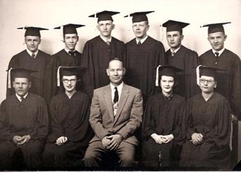
Back-L to R-Earl Johnson, Vernon Benjaminson, George Kristjanson, Richard Bjornson,
David Hillman, Orin Steinolfson

Front-L to R-Oscar Byron, Janyce Gudmundson,
Supt. Glenn Lian, Shirley Gudmundson,
Veronica Byron
Class of 1958 Plans 50 Year Reunion
The Mountain High School graduating class of 1958 is planning a reunion during the August the Deuce Celebration in 2008. Further information will be provided in the next issue of the Fjalla Blad in June or July as the exact date and location have not been finalized, although it will be in Mountain. The "Class of 58" welcomes any input, ideas, or information, so feel free to contact either Dave Hillman at 701-549-3829 or djohn@utma.com, Oscar & Shirley Byron at 701-993-8660 or afi@polarcomm.com, or Richard & Janyce Bjornson at 701-222-8558 or frmrhp@bis.midco.net.

2007 Kraksson & Sigurdson Reunion

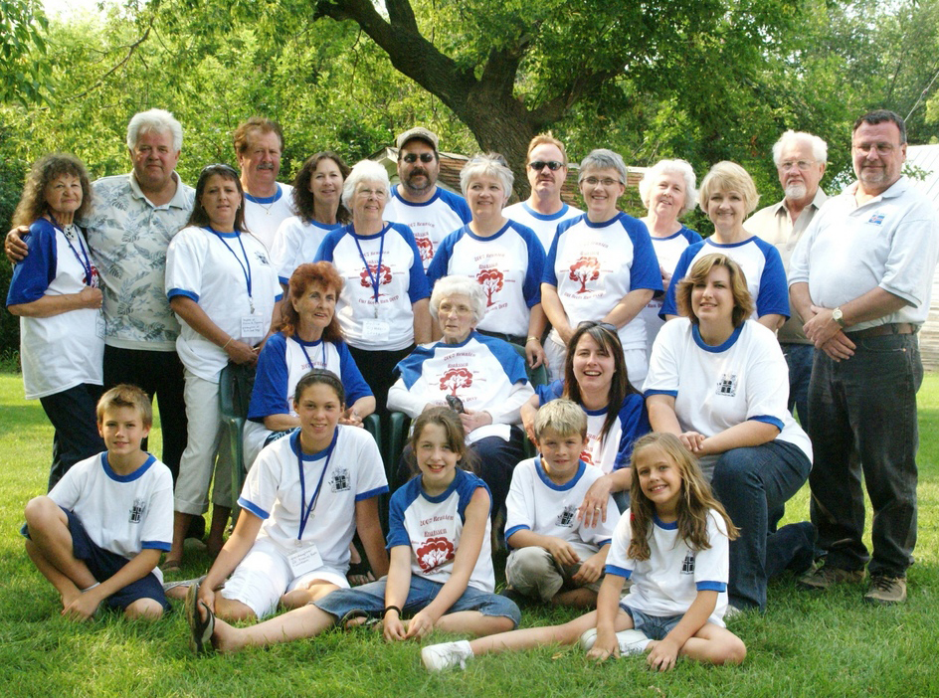

"They came with hope, seeking opportunity, but they found hard work and often hard times.
H. Edwards

"Back to a Beginning"
by Shirley Jo Sigurdson

Pioneer Sigurdur Kraksson with wife Kristin Thorsteinsdottir and their son came from Iceland to New Iceland, Manitoba, Canada where their son died in an epidemic. They came with hope, seeking opportunity, but they found hard work and hard times. With no good fortune, they went to Pembina County, Dakota Territory, where they homesteaded on land four miles south of where the town of Mountain was later settled. They built a sod house, then a log cabin and finally the house that still stands. Now called the Sigurdson farm, it was declared a centennial farm by the state of North Dakota.

Their 12 children, seven (7) lived to adulthood, were registered ‘Sigurdson’ from the given name of their father Sigurdur. Records show that the girls used the name as well and the ‘s’, for possession, was dropped. Families continued to use what was called the ‘American way’ and to this day are known as ‘Sigurdson’ families.

THE REUNION

The Sigurdson girls, Judy Olafson, Kathy Thorlakson, Susan with husband Tim Powers and mother Sigrun Sigurdson hosted over 40 relatives ranging in age from over 90 to under 6 years and every age in between, including a four generation family.
Everyone shared in rulapylsa brown bread sandwich, lots of goodies and beverages.
The elders had a story to tell, the youngsters climbed thru barn lofts and some took to the south 40 and came up with a few relics. Cameras clicked and grinded as those who had attended the old school house recalled the ring of the bell that now sits surrounded by flowerbeds. Sad & sweet feeling as the goodbyes were said concluding 3 days of hurry FRANTIC one after another events of Food, FUN and FROLIC of FAMILY and FRIENDS.
Many of the ‘Kraksson Klan’ stated that the highlight of the Kraksson/Sigurdson 3 day reunion was the Sunday afternoon visit to the ‘Old Farm’. Sixth generation youngsters came from Washington and Utah to attend the Kraksson/Sigurdson reunion. They spent the last day romping and exploring the Sigurdson Farm.

"Whether young or old, you need to know you belong to a Klan."
Pete Nelson

2007 Gestsson Reunion

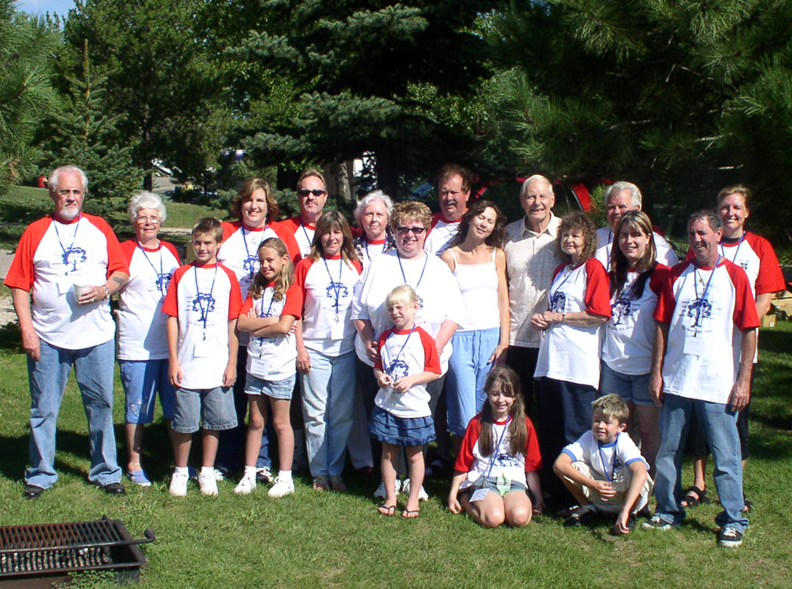

"Those who have forgotten the past have nothing to offer the future." …Thomas Macaulay
by Shirley Jo Sigurdson

Gudni Gestsson traveled to North America by boat to Canada and joined the Icelandic immigrants in the Pembina County, Dakota Territory. He married Gudlaug Jonsdottir who also had come to America. They were able to homestead on land 5 mile south of what later was to become the town of Mountain, North Dakota. This union had 4 children before Gudlaug died leaving these all very young ones for Gudni to raise.
My grandfather, hearing of a woman who needed work, hired Anna Kristjandottir. She brought her 4 children with her and was later joined by a son from Iceland. My Afi Gudni married this lady who became my Amma. To this union my mother Ruth was born and later joined by a sister. The two girls instantly had 9 siblings, making 11 who all married locally. My mother married a widower with 2 small children Beggi Sigurdson (Kraksson). To this union 11 children were born to them in the Mountain community. After traveling to Seattle, Washington, 2 boys were born. I was born and raised in a family of 15 plus my parents.
We became both Gestsson and Kraksson descendents.
Six of us, along with our extended family including 5th and 6th generations, 18+ in all, traveled from five different US states to attend both the Gestsson and Kraksson reunions held over the "Deuce', Icelandic August 2nd celebration, held as a 3 day event in Mountain, N.D. It was a most eventful and pleasurable time for all of us.
"Hey! Wasn't that a Gestsson?" Sure enough it was! Gestsson descendants came from North Dakota, Minnesota, Utah, Arizona, Nevada and Washington for a 3-day reunion and to attend the 'Deuce' in Mountain, N. Dakota.
Friday morning began at the Icelandic State Park amphitheater with a detailed genealogy presentation by Pam (Olafson) Furstenau tracing our ancestors back to their early Icelandic beginning. She told wonderful stories and displayed a surprisingly large, easily seen by all, genealogy chart.
We then enjoyed an excellent Icelandic farmer style champagne brunch with, of course, the famous North Dakota red potatoes and a toast with "Brennivin", a gift from the Icelandic Consulate to the families of Gestsson descendents. Suzanne Larson, on the piano, accompanied the singing of the American and Iceland anthems and played Icelandic tunes while everyone said hello and visited.
The table settings were elegant with linen cloths, china plates and gourmet food, presented by Thompson of Cavalier… like the cover of a Bon Appètit Magazine.
A short brunch program included comments from our 2 prestigious guests from Iceland, Almar Grímsson, President of the Icelandic National League, and Valgeir Thorvaldsson, Managing Director, Icelandic Emigration Center, and a humorous/knowledgeable Icelandic slideshow narrated by Dr. Bob Gestson.
After a delicious dessert table of ponnukokur both rolled & and fruit filled with fresh heavy sweet cream, vinarterta and bread pudding, the gang went on a tour of the Icelandic Park Pioneer Heritage Buildings & Museum then crossed the street to tour the Pembina County Historical Museum.
Next on the agenda was the ceremony to unveil the 6.5 foot bronze Christus Statue and the dedication of the wild garden at Thingvalla Lutheran Church. A moving program that included several hundred people… the majority from afar.
Afterwards, some went to Mountain to participate in the Deuce activities with Dancing in the street until wee hours.
It was up early Saturday morning for the parade and spending the day taking advantage of the many events, booths, foods, exhibitions and the genealogy house. Most everything offered was free and attended by volunteers. (continued)

A Heritage program was offered on the lawn of Borg Home with keynote speakers Prime Minister Geir H. Haarde and North Dakota Governor John Hoeven and two choirs from Iceland.
Some enjoyed visiting original homesteads and historical sites, such as Vikur Church, the oldest Icelandic church in North America, the memorial stone dedicated to Sylvia Johnson, a most influential relative who gave so much to the community and state, or reading old tombstones at Vikur and other resting places in the Mountain, and Thingvalla Cemeteries in hopes of finding names of ancestors.
Saturday night was spent at Icelandic Park in a wagon train type atmosphere of RVs in a circle around a large campfire singing songs and exchanging remembered stories.
Sunday's religious ceremony was offered on the lawn of Borg Home followed by a catered picnic dinner and more visiting.
The end of day was filled with goodbyes, tears, and smiles promising to meet again. Each was filled with the sadness of leaving their roots to return to their futures.
Much of the 3day's most exhausting schedule, but most rewarding and fulfilling experience was shared with the Kraksson/Sigurdson reunion. As many came to attend of both ancestries.

BORG HOME AUXILIARY BAZAAR AND BAKE SALE
The Borg Home Auxiliary held their Annual Bazaar and Bake Sale on September 22, 2007, at the Borg Home In Mountain. The event was a great success and $2,485.13 was the gross earnings.
Three raffle prizes were awarded. A denim quilt donated by Evie Holand was won by Bev Bliken, Grand Forks; an ivory colored afghan donated by Jean Smillie went to Marlene Johnson, Cavalier; and a doily made by JoAnn Hardy was won by Tyrone Byron, Mountain.
The Borg Auxiliary appreciates everyone who donated items or worked to help make their 2007 bazaar a success.

“Looking”
One of our members is looking for a copy of the Mountain, ND 1961 WarHawk annual.
If anyone can help- Contact, Bessie Machacek at 701-256-5558 or E-Mail-betsymac@UTMA.com

The 2008 Membership drive is underway.
Membership runs from Jan. thru Dec.
$10.00 per person.

Editor’s Note: After the newsletter went to print two more sponsors were added to the MCCCC Corporate Sponsors List. They are:
Choice Financial-Walhalla $2,500 and Choice Financial-Langdon $2,500

Dance to the music of your dreams; the steps will bring you joy.

Góða nótt!

