126TH ANNUAL

Deuce of August Icelandic Celebration
Árið tvö þúsund og tuttugu fimm (2025)
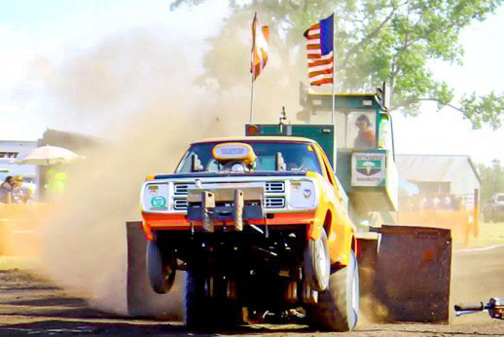
Mountain, North Dakota
The schedule will be updated with new events as they become available. For current information, visit our website: thedeuce.org.
SUNDAY, JULY 27TH– MONDAY, AUGUST 4TH
“The Icelandic Emigration Journey” Poster Exhibit at Gardar Pioneer Church
FRIDAY, AUGUST 1ST
“Friday Forum at the Deuce” - Mountain Community Center
To register for this event and the lunch: icelandicroots.com/event-calendar
12:00 PM Free Lunch for attendees of the afternoon presentations. Sponsored by Icelandic Roots.
12:15 PM: "The Icelandic Emigration Journey," Sunna Olafson Furstenau
12:30 PM: "Weaving History with Njal's Saga Tapestry," Claudia Petursson
12:55 PM: "Bloodlines & Ballads”: “Finding Ourselves in Icelandic Sagas," Jason Doctor
1:15 PM: "The Wild Weather of North Dakota and Iceland," Aaron Kennedy, UND
2:00 PM: "Free Genealogy Center and Free Access to the Icelandic Roots Database"
12:00 PM Souvenirs – MCC Chair Room – 12:00 Noon – 3:30 PM
3:00 PM Icelandic Ólafsson Gin and Reyka Vodka “Gleðistund fyrir alla” (Happy Hour for everyone!)
Gardar 10th Hole Country Club 3:00 to 5:00 PM
Disc Golf all day – Gardar - Bring your own disks or borrow from the Country Club

5:00 PM Mountain American Legion Fish Fry - Main Street - 5 PM - 7 PM
7:00 PM Icelandic Bingo – to benefit Borg Auxiliary
8:00 PM Street Dance “Whiskey Wheeler” 8 PM – 11 PM Free admission

SATURDAY, AUGUST 2ND
7:00 AM Pancake and Sausage Breakfast – Mountain Chalet Café - 7 - 10 AM
8:00 AM Life in the Vast Lane 5K – Assemble at Legion Grounds.
Registration Hub
Run/walk to the top of Schroeder Hill - Bus return to Mountain
9:00 AM Souvenirs – 9 AM – 3:30 PM across from Vikur Church
Icelandic Goodies - Main Street- 9 AM to 2 PM (or until gone)
10:30 AM Parade - Main Street - Broadcast live on KXPO AM 1340 and Live on ICA Facebook page
11:00 AM Vikur Salad Luncheon - Vikur Church basement
11:00 AM Icelandic Roots Genealogy Center - Mountain Community Center - 11 AM - 2 PM
12:00 PM Car Show and Shine - Main Street - Music by “Kenny and The Classics”
12:00 PM Children’s Icelandic Story Time in Amma’s Garden – Kathy Thorlakson lawn N of MCC
12:30 PM Kid’s Inflatable Games - North end of Main Street from 12:30 - 4 PM
12:30 PM Pedal Tractor Pull for Kids - Main Street - ND State Sanctioned Pull - Olson Pedal Pulls
1:30 PM Horse Show – West of MCC – Bring your horse for the parade and the show!
2:00 PM Heritage Program – Borg Home Lawn - Bring your lawn chairs!!
Iceland Combined Men’s Choirs Karlakór Hreppamanna and Sprettskórinn
Her Excellency Svanhildur Hólm Valsdóttir, Iceland Ambassador to the US-Keynote 3:00 PM Bean Bag Tournament - Main Street
5:00 PM Street Dance “Homestead Band” – Main Street – 5 - 8 PM Free admission
9:00 PM Street Dance “Kickin Back” - Main Street - 9 PM - 1 AM Free admission

SUNDAY, AUGUST 3RD
11:00 AM Worship Service - Vikur Church - Light brunch to follow worship service
1:00 PM North Dakota State Tractor & Pickup Pulling Contest - West of Mountain Community Center
Admission $20 for adults - 15 and under free

Parade Marshal: Duane Geir ~ Honorary Parade Marshal: J. Vilmar Kristjanson
Check for updates at TheDeuce.org

